Practical No. :- 6 Date :- 02/14/2023

Q.) From a batch of 1000, the life time of picture tables of TV have normal distribution with mean 10 years and s.d of 2 years.
1.) What is the probability that such picture table has life time between 8 and 10 ?
2.) Find the percentage of pictures tables having the life time greater than 9 years.
3.) Find the number of picture tables having the life time more then 10.5 years.

Solution :-

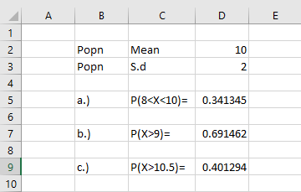

Formula Used. :-
- =NORM.DIST(D2,10,D3,TRUE)-NORM.DIST(8,D2,D3,TRUE)
- =1-NORM.DIST(9,D2,D3,TRUE)
- =1-NORM.DIST(10.5,D2,D3,TRUE)

Practical No. :- 7 Date :- 02/14/2023

Q.) Suppose that Service life of Semi-Conductor is a random variable having expential distribution with (lemda) = 1/50 hours . Find the prob. That such Semi-Conductor will be , still operating after 100 hours.

Solution :-
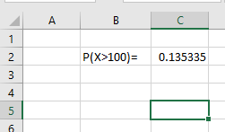

Formula Used :-
P(X>100) =1-EXPON.DIST(100,1/50,TRUE)

Hence ,
The Prob. That Such Semi-Conductor will be still operating after 100 hours is 0.135

Practical No. :- 1 Date :- 02/12/2023
Q.) from the following data
X | 0 | 1 | 2 | 3 | 4 | 5 | 6
P(X=x) | 0.18 | 0.28 | 0.25 | 0.18 | 0.06 | 0.04 | 0.01

- Find expected number and Variance of hardware failure in a week.
- Find E(4X+2)
- Find V(2X+3)
Solution :-
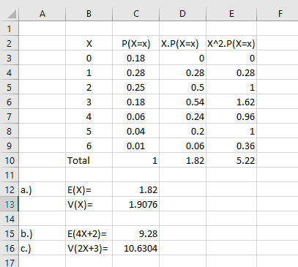

Formula used :-
X.P(X=x) =B3*C3 ,
Sum =SUM(D3:D9)
X^2.P(X=x) =D3*B3
Sum =SUM(E3:E9)
Sum P(X=x) =SUM(C3:C9)

Formula Used :-
- E(X) =D10
V(X) =E10-D10*D10
- E(4X+2) =4*C12+2
- V(2X+3) =2*2*C13+3

Practical No. :- 08 Date :- 02/15/2023

Q.) The number of Sick days due to colds and the last year was record by a sample of 15 aduts . The data are 2,0,5,7,0,3,15,6,5,9,3,8,10,5,12.
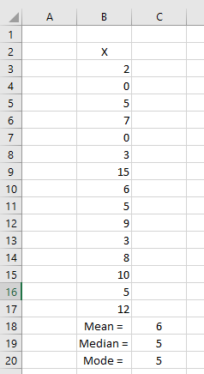
Solution :-

Formula Used :-
Mean =AVERAGE(B3:B17)
Median =MEDIAN(B3:B17)
Mode =MODE(B3:B17)

Conclusion :-
- Average number of Sick days due to colds and the last year was 6 days.
- The number of aduts whose Aick days are below 5 and the number of aduts whose Sick days above 5 are equal ( same )
- The most separate number of sick days is 5
Practical No. :- 9 Date :- 02/15/2023

Q.) Following are the weight ( in lbs ) of five items 120,180,140,150,160
Find .
- Standard deviation and Variation.
- Quartile Deviation
- Coeffiecient of Variation.
Solution :-
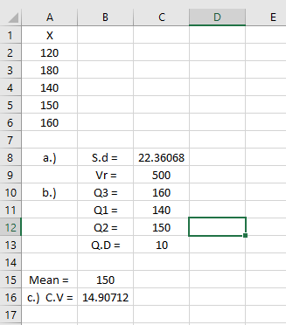
Formula Used :-
Mean =AVERAGE(A2:A6)
- S.d. =STDEV(A2:A6)
V.r. =VAR(A2:A6)
- Q1 =QUARTILE(A2:A6,1)
Q2 =QUARTILE(A2:A6,2)
Q3 =QUARTILE(A2:A6,3)
- C.V =(C8/B15)*100
Conclusion:- Average deviation of the given give items from the mean 150 is 22.36 lbs.
Practical No. :- 10 Date :- 02/15/2023
Q.) From the following data
Determine which Plant is more Uniform.
Plant A | 5.62 | 5.29 | 16.25 | 10.92 | 11.46
Plant B | 9.54 | 11.46 | 16.62 | 12.62 | 25.75

Solution :-
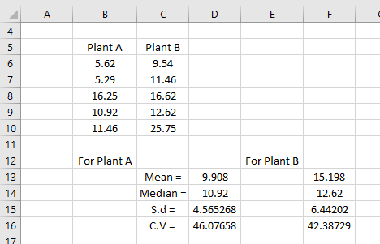
Formula Used :-
For Plant A For plant B
- Mean =AVERAGE(B6:B10) =AVERAGE(C6:C10)
- Median =MEDIAN(B6:B10) =MEDIAN(C6:C10)
- S.d =STDEV(C6:C10) =STDEV(C6:C10)
- C.V =(D15/D13)*100 =(F15/F13)*100

Conclusion :-
Hence , C.V of Plant B is less then C.V of Plant A so that Plant B is more Uniform.

Practical No. :- 11 Date :- 02/15/2023
Q.) Test whether the following distribution is Symmetrical or not.
173 , 206 ,179,257,198,251,239,246,295 & 261

Solution :-

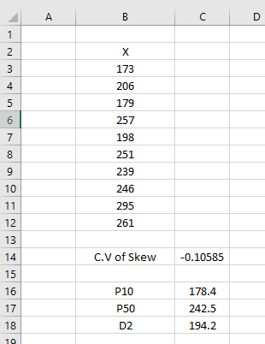

Rough :-
Formula Used :-
P10 =PERCENTILE(B3:B12,10/100)
P50 =PERCENTILE(B3:B12,50/100)
D2 =PERCENTILE(B3:B12,2/10)

Formula Used :-
- C.V of Skew =SKEW(B3:B12)

Conclusion :-
The given distribution is not Symmetrical.

